PIZZA SALES SQL QUERIES
A. KPI’S
1. Total Revenue
SELECT SUM(TOTAL_PRICE) AS TOTAL_REVENUE FROM [pizza_sales (1)];
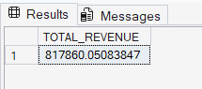
2. Average Order Value
SELECT SUM(TOTAL_PRICE) / COUNT(DISTINCT ORDER_ID) AS AVG_ORDER_VALUE FROM [pizza_sales (1)];
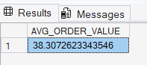
3. Total Pizza Sold
SELECT SUM(QUANTITY) AS TOTAL_PIZZA_SOLD FROM [pizza_sales (1)];
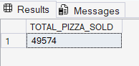
4. Total Orders
SELECT COUNT (DISTINCT ORDER_ID) AS TOTAL_ORDERS FROM [pizza_sales (1)];
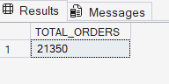
5. Average Pizzos Per Order
SELECT CAST(SUM(QUANTITY) AS DECIMAL(10,2)) /
CAST(COUNT(DISTINCT ORDER_ID) AS DECIMAL(10,2)) AS AVG_PIZZOS_PER_ORDERS FROM [pizza_sales (1)];
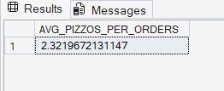
SELECT CAST(CAST(SUM(QUANTITY) AS DECIMAL(10,2)) /
CAST(COUNT(DISTINCT ORDER_ID) AS DECIMAL(10,2)) AS DECIMAL(10,2)) AS AVG_PIZZOS_PER_ORDERS FROM [pizza_sales (1)];
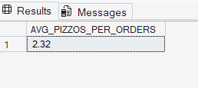
CHARTS
1.Daily Trend for Total Orders
SELECT DATENAME(DW, ORDER_DATE) AS ORDER_DAY, COUNT(DISTINCT ORDER_ID) AS TOTAL_ORDERS FROM [pizza_sales (1)]
GROUP BY DATENAME(DW, ORDER_DATE);
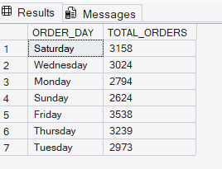
2. Hourly Trend for Total Orders
SELECT DATEPART(HOUR, ORDER_TIME) AS ORDER_HOURS, COUNT(DISTINCT ORDER_ID) AS TOTAL_ORDERS FROM [pizza_sales (1)]
GROUP BY DATEPART(HOUR, ORDER_TIME)
ORDER BY DATEPART(HOUR, ORDER_TIME);
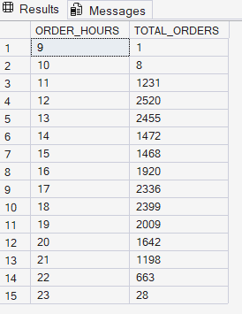
3. Percentage of Sales by Pizza Category
SELECT PIZZA_CATEGORY, SUM(TOTAL_PRICE) * 100 / (SELECT SUM(TOTAL_PRICE) FROM [pizza_sales (1)])AS PCT
FROM [PIZZA_SALES (1)]
GROUP BY pizza_category;
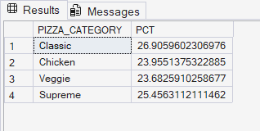
4. Percentage of Sales by Pizza Size
SELECT Pizza_size, SUM(TOTAL_PRICE) AS TOTAL_SALES, SUM(TOTAL_PRICE) * 100 /
(SELECT SUM(TOTAL_PRICE) FROM [pizza_sales (1)]) AS PCT
FROM [pizza_sales (1)]
GROUP BY PIZZA_SIZE;
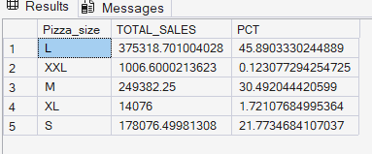
5. Top 5 Best Sellers by Total Pizzas Sold
SELECT PIZZA_CATEGORY, SUM(QUANTITY) AS TOTAL_PIZZAS_SOLD FROM [pizza_sales (1)]
GROUP BY PIZZA_CATEGORY;
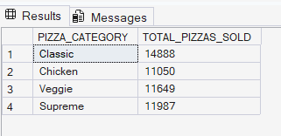
6.Bottom 5 Worst sellers by Total pizzas sold
SELECT TOP 5 pizza_name, sum(quantity) AS TOTAL_PIZZAS_SOLD
FROM [pizza_sales (1)]
GROUP BY PIZZA_NAME
ORDER BY SUM(QUANTITY) DESC;
SELECT TOP 5 pizza_name, sum(quantity) AS TOTAL_PIZZAS_SOLD
FROM [pizza_sales (1)]
GROUP BY PIZZA_NAME
ORDER BY SUM(QUANTITY) ASC;
